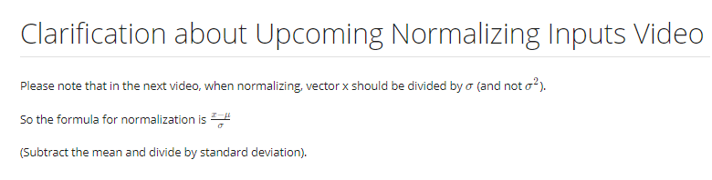

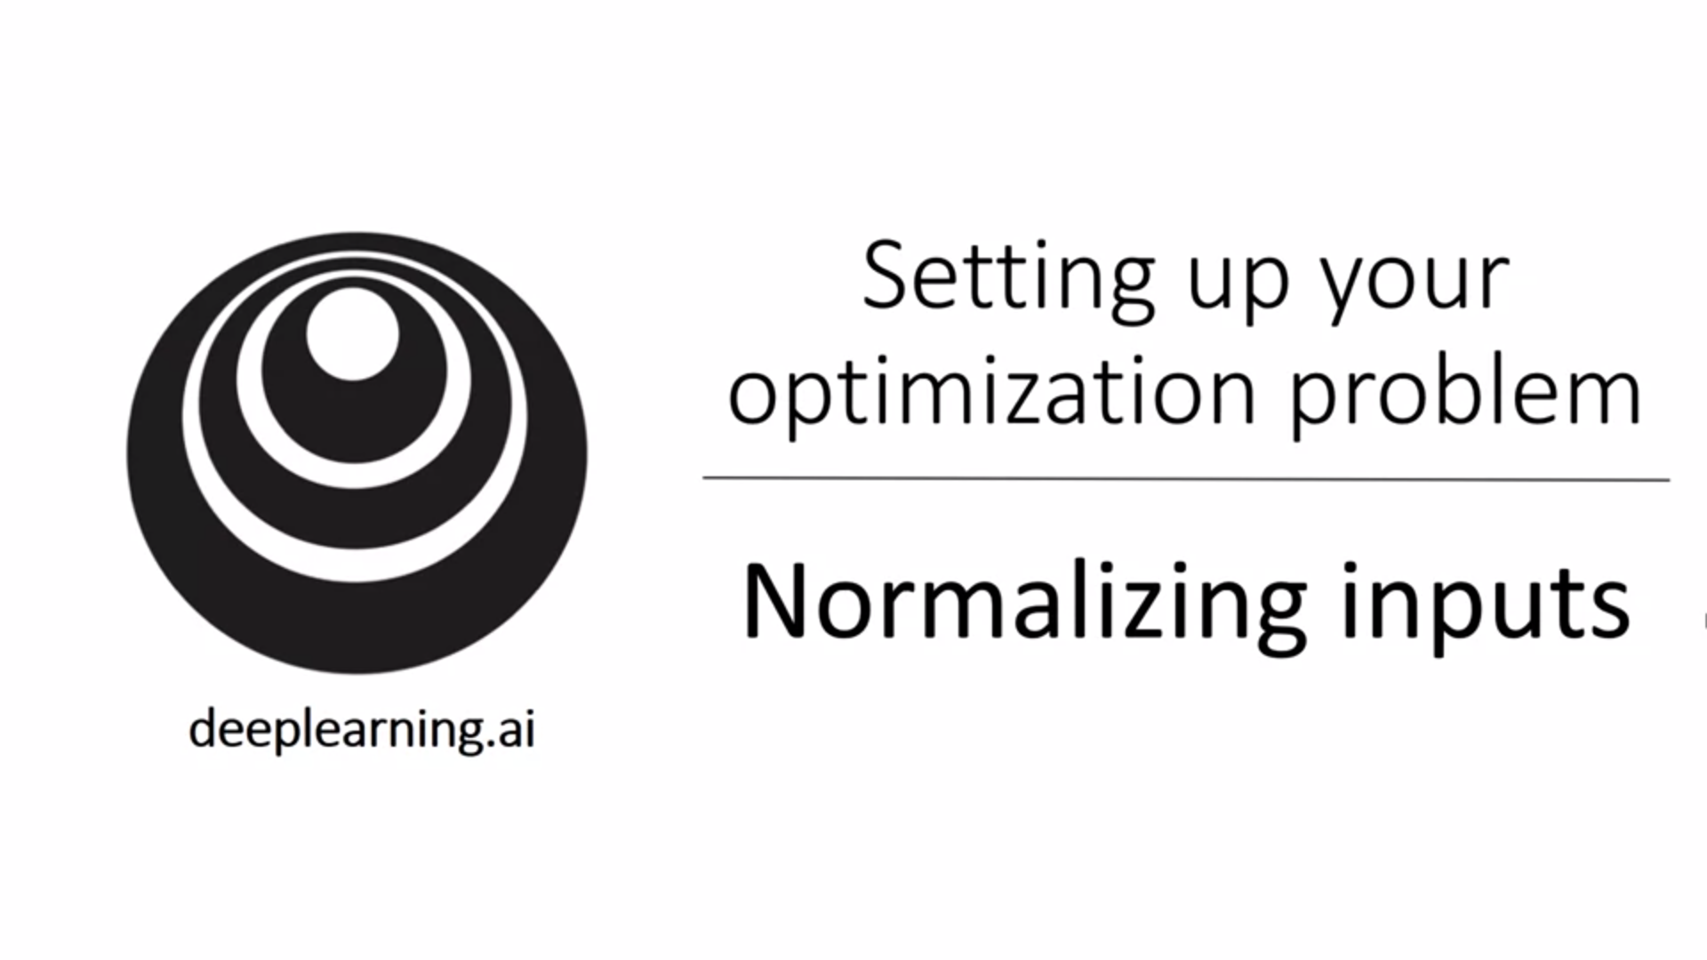

One of the techniques of speeding up training is to normalize inputs.

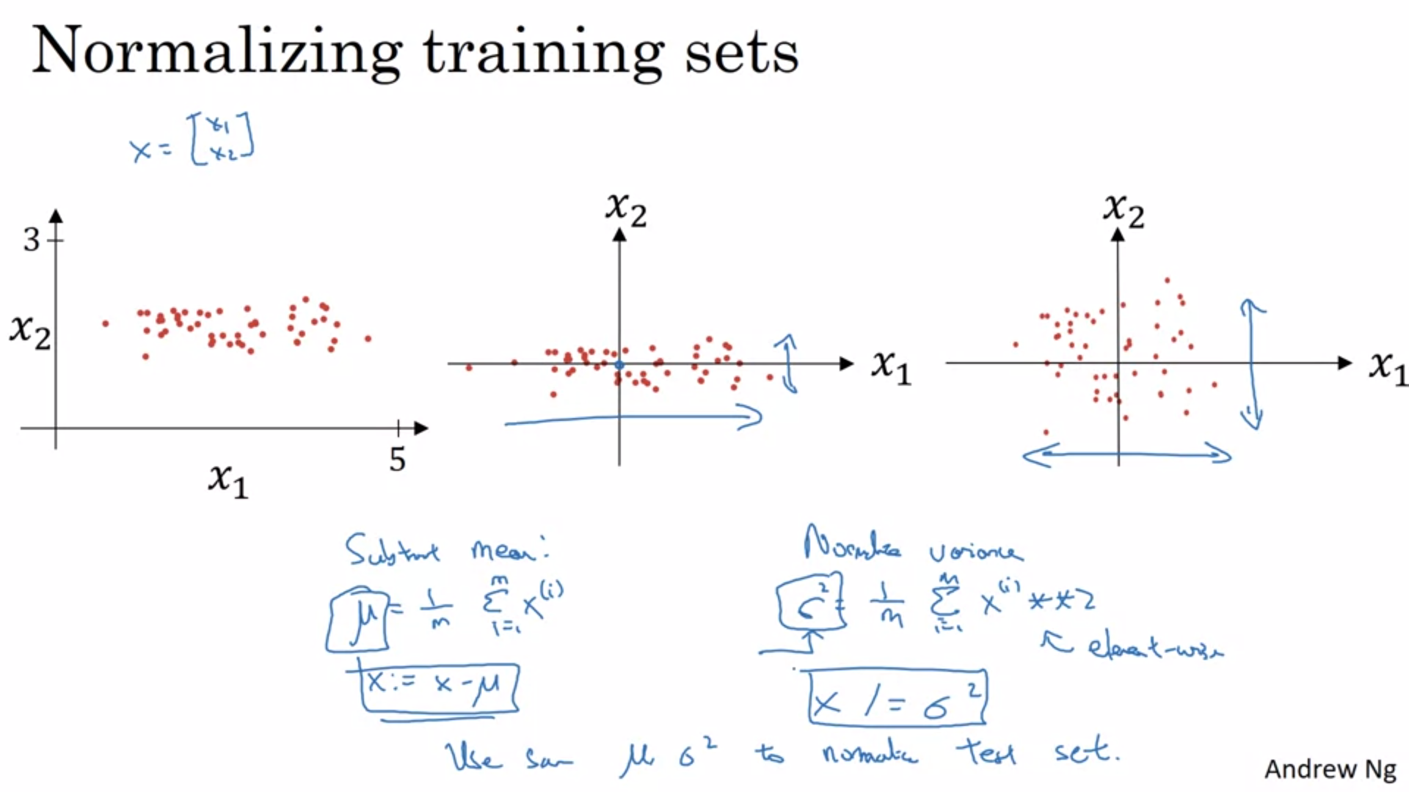

Normalizing corresponds to two steps: subtract out the mean, divide by variance.

Use the same mu and sigma**2 for the train and test set! Test set has to be scaled in exactly the same way.

Calculate mu and sigma**2 on the training data.

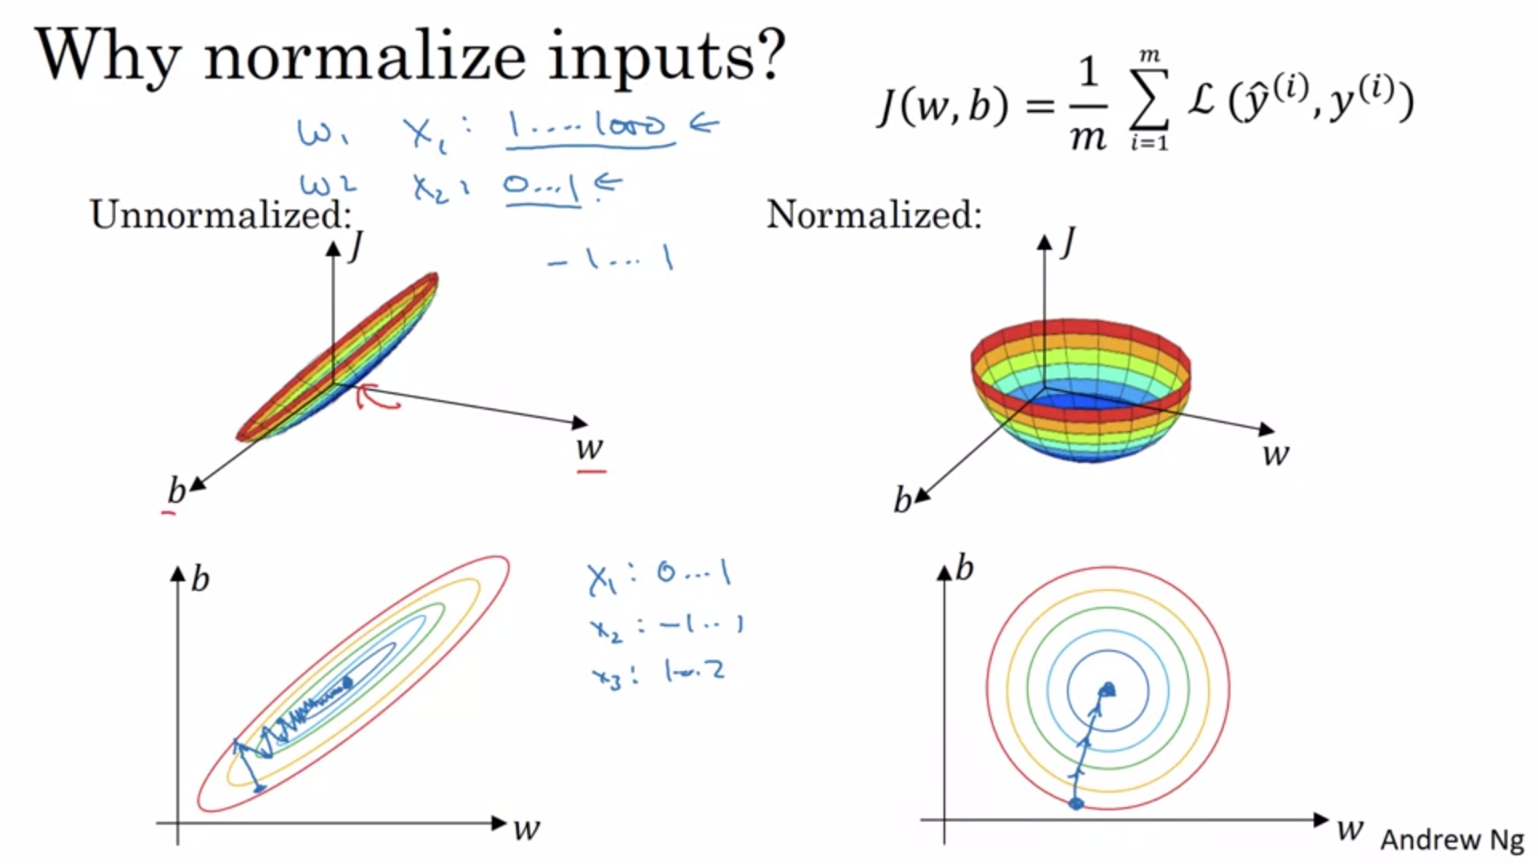

If unnormalized (and features on very different scale), the cost function can look very elongated.

W, b here should be w1 and w2.

Gradient descent will then need a lot of steps.

For normalized data, gradient descent can go right to the minimum.

Of course in reality this is high-dimensional but the intuition holds.

0 to 1 and -1 to 1 is fine in practice (this is similar enough).

Normalizing is especially important if the features come from different ranges (e.g. factor 1000).

Normalizing never does any harm so we can just do it in general.

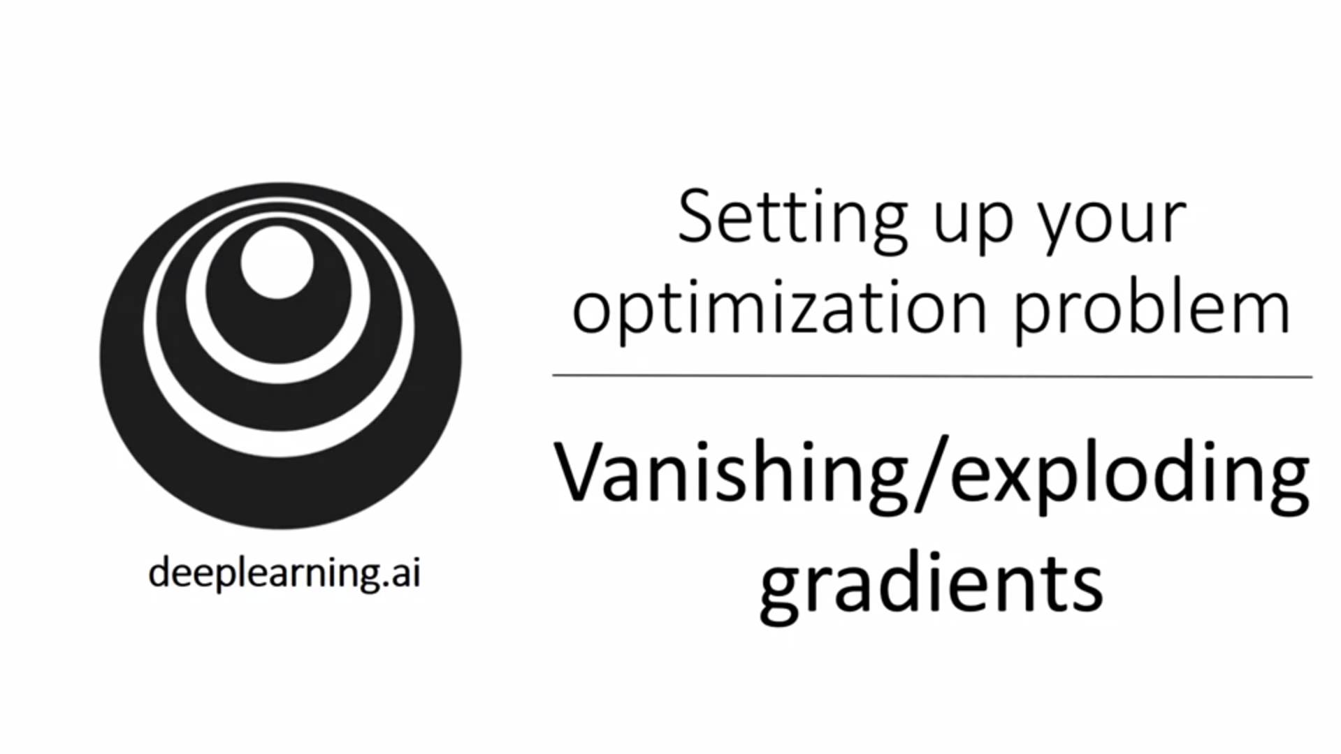

One of the problems when training neural networks, especially very deep neural networks.

The derivatives can become very big or very small. This makes learning / training difficult.

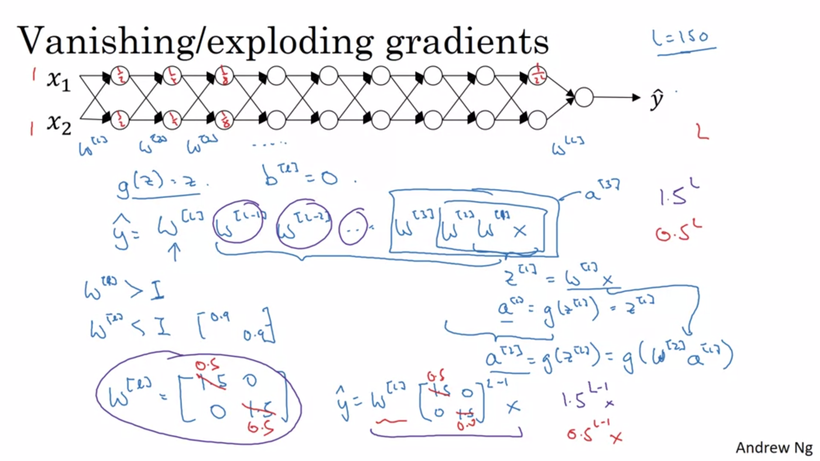

Let’s look at a very deep neural net as example.

For the sake of simplicity we will use a linear activation function.

If each of the weight matrices is just a bit bigger than the identity matrix then y_hat will grow exponentially with that factor. The same applies if weight matrices are a bit smaller than the identity matrix. Then y_hat will shrink exponentially with that factor. This effect gets more prominent the deeper the network.

Here we look at weight matrices but the same holds for gradients also.

Microsoft recently released a network with 150 layers.

This makes training difficult as gradient descent will take tiny little steps.

There is a partial solution to this problem: careful choice of how to initialize weights.

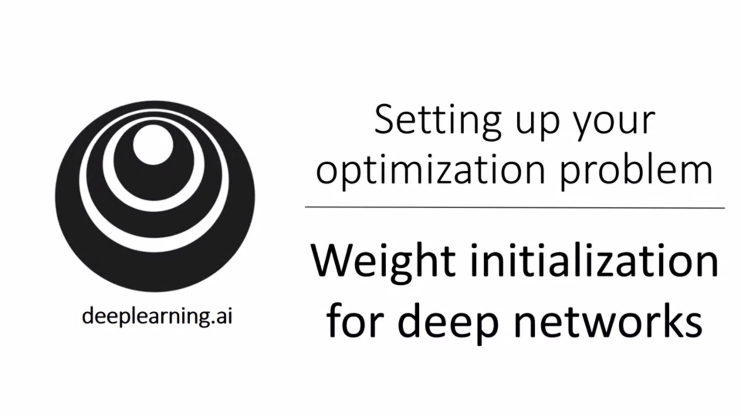

We start with an example of a single neuron first.

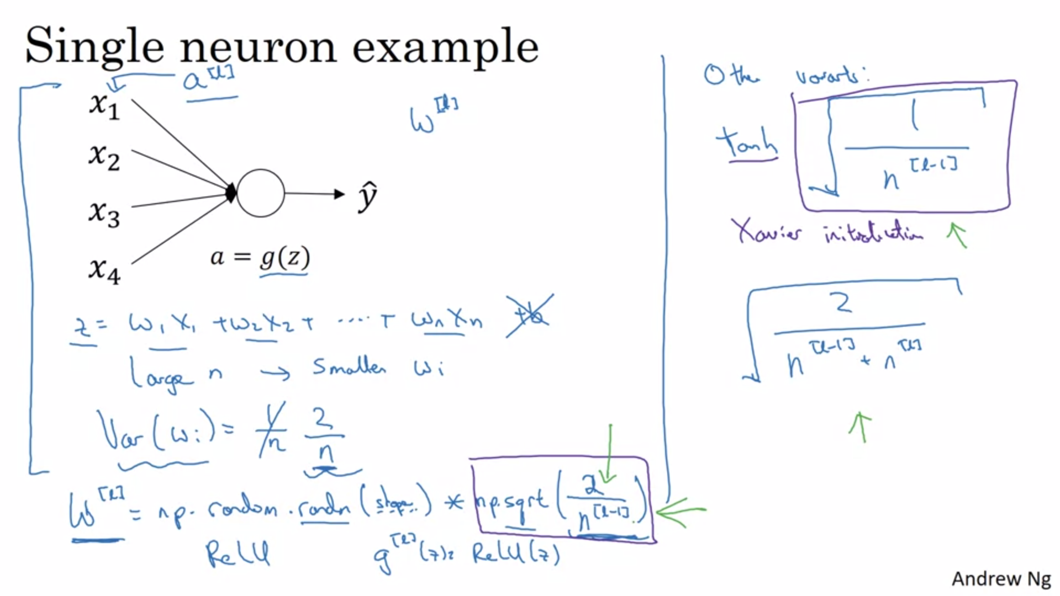

In order to make z not blow up and not become too small, the larger n is the smaller w_i has to be.

Use n[l-1] in the formula. This is the number of neurons that are feeding into the layer.

Setting the variance to 2/n was empirically shown to work better with relu.

By using a Gaussian random initialization and multiplying with the variance, we set the variance to our multiplication factor.

If the input features / activations are normalized, this will cause z to take on a similar scale. It does not solve the vanishing / exploding gradient problem but certainly helps. It will ensure that the w’s are not too much bigger or smaller than 1.

For tanh activation it is better to choose the term on the top right -> Xavier Initialization.

The variance could be another hyperparameter to tune.

It’s not one of the first hyperparameters that Andrew would try to tune.

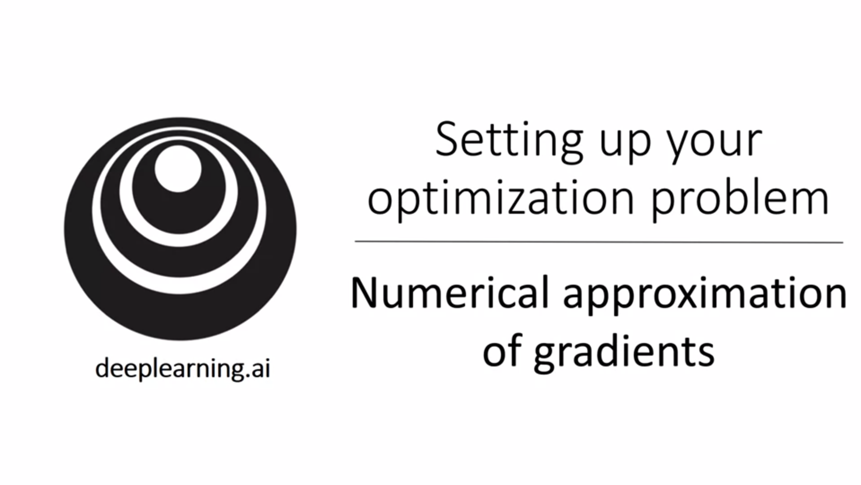

Gradient checking can help you to make sure that your backpropagation implementation is correct.

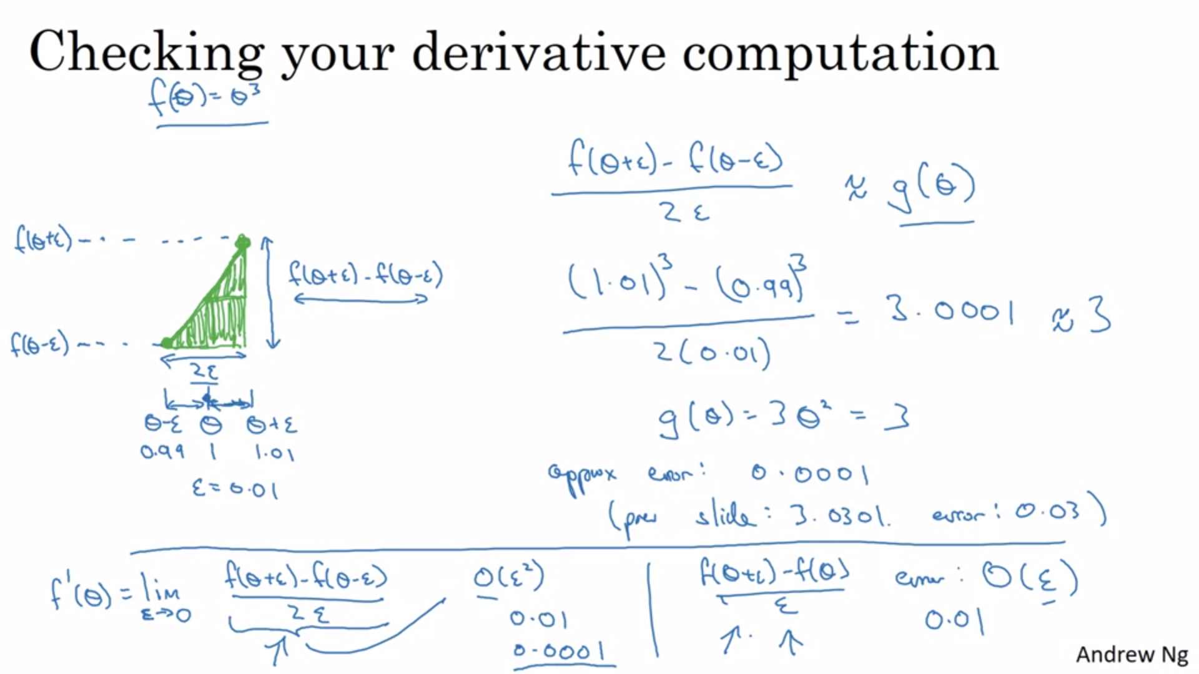

You can get a much better estimate of the gradient when you go to the right and left from your point (basically you have two triangles).

Height/width.

The approximate error is much smaller than with a one-sided triangle.

This is twice as slow as a one-sided difference.

The formal definition of a derivative is a two-sided limit. The error is on the order of epsilon**2. With the one-sided difference the error would be on the order of epsilon.

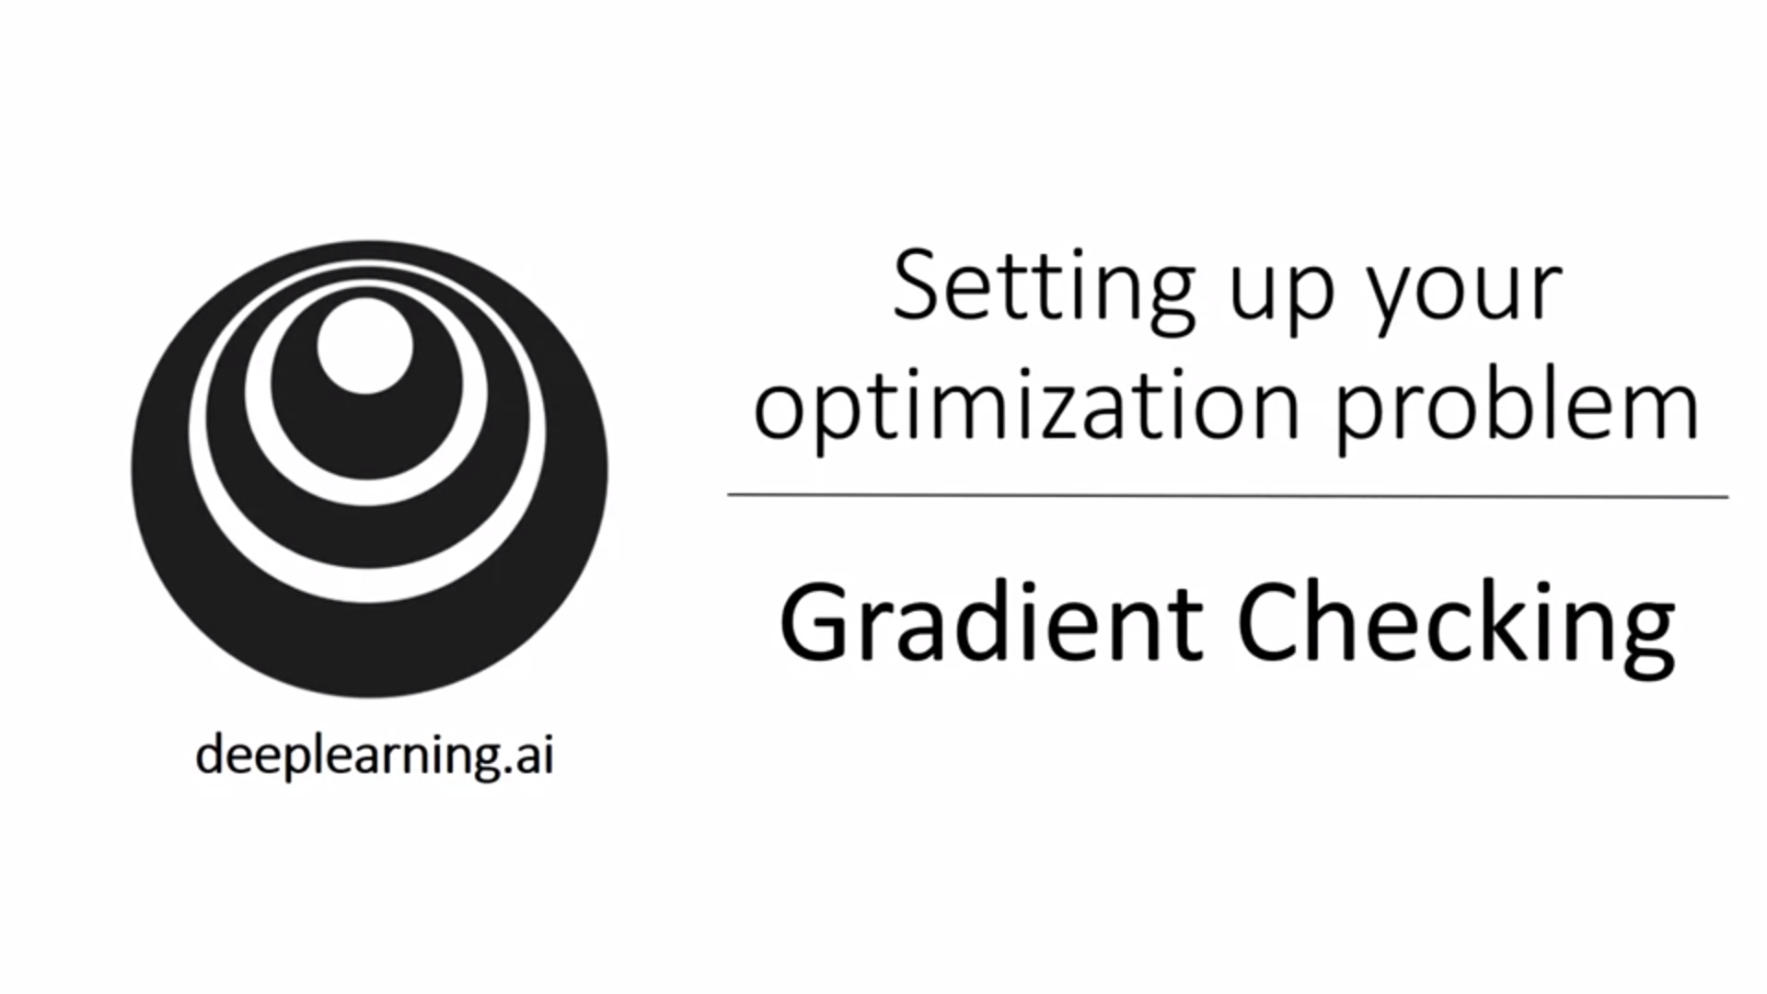

Let’s see how we can use the numerical approximation of gradients to ensure that our backprop implementation is correct.

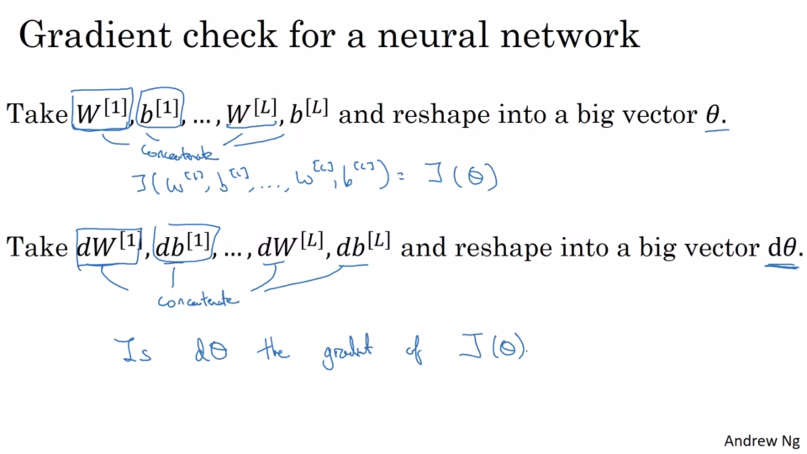

This has helped Andrew to save tons of time when debugging.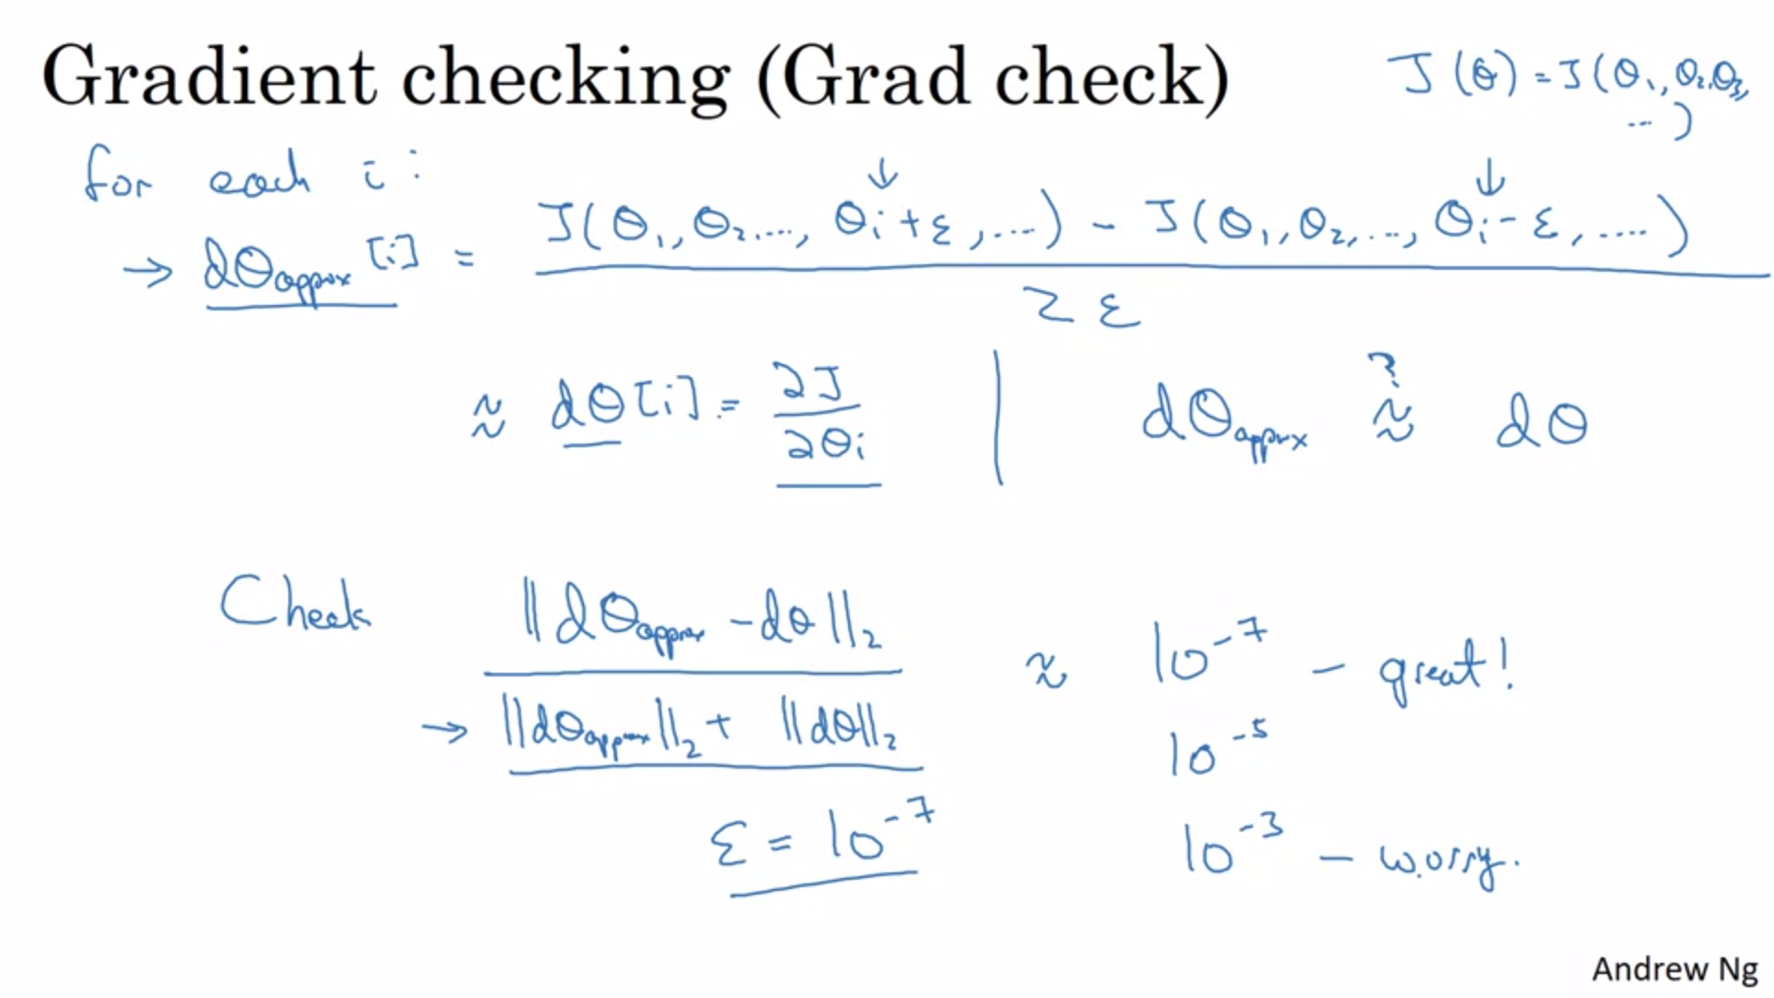

For each component of theta, take a two sided difference (nudge it with epsilon).

Compute the Euclidean distance between dtheta_approx and dtheta. The denominator turns the formula into a ratio (to account for large values of dtheta for example).

If it is not the same, track it down to a specific theta!

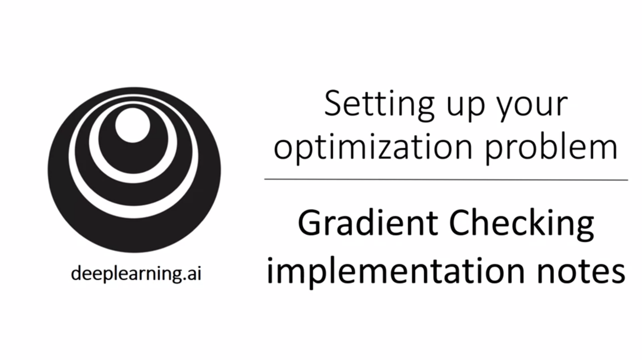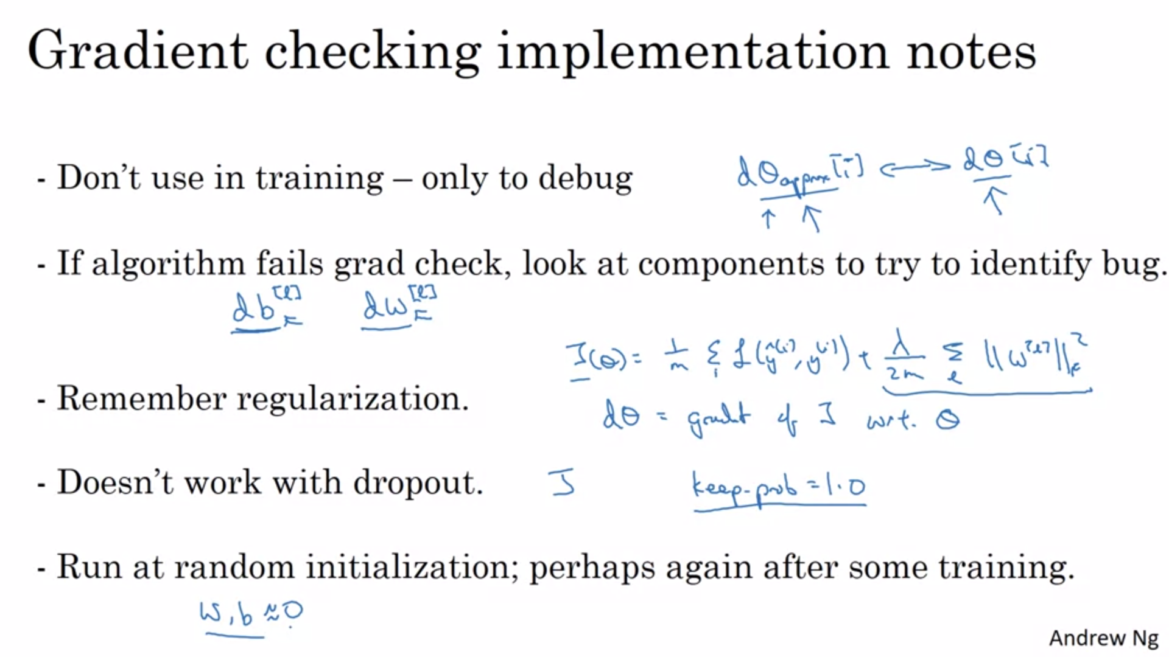

Gradient checking is very slow computationally -> only use it in debug and then turn it off!

Run gradient checking without dropout, then turn on dropout.

It is possible (although rarely happens) that the implementation of backprop is correct when w, b are close to 0 but is incorrect for large values -> run grad check again after some number of iterations.